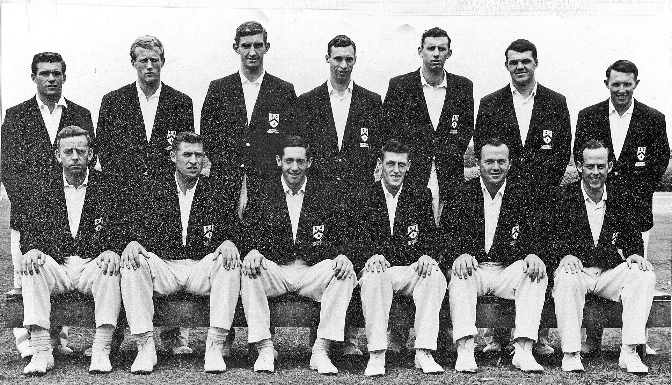

**Canterbury representative Team 1964/65**

**Back row:** RM Gearry, PA Sharp, B Andrews, BG Hadlee, BR Taylor, IR Hartland, JR Veitch

**Front row:** JW Kiddey, RC Motz, GT Dowling (captain), JT Ward, K Thomson, BF Hastings